**1050 Programming Logic**

Lab 11 (20 points total)

Name: ___Megan Ostrander______

***Instructions:*** *Complete the following exercises. Paste your code and screenshots into this document and submit this Word document to Blackboard when complete.*

1. Create a 12-element array called months. Set each element to the name of each month.

For example months[0] = “January”. Use a for loop to display the number and name of each month. (5 points)

using System;

using System.Collections.Generic;

using System.Linq;

using System.Text;

using System.Threading.Tasks;

namespace MonthArray

{

class Program

{

static void Main(string[] args)

{

//creates array containing months of year, in order.

string[] Months = {"January", "Febuary", "March", "April", "May",

"June", "July", "August", "September", "October", "November", "December"};

//Note: need ; after "int counter = 0" so rest of conditions in for statement function!

//while counter is less than length of array print array counter and month.

for (int counter = 0; counter < Months.Length; ++counter)

{

Console.WriteLine($"{counter +1} {Months[counter]}");

}

//Note: using Months[] results in displaying error message

//using Months[0] results in only displaying Janurary for each counter.

//Need to use Months[counter] to properly display each array entry with the corrisponding counter number

//can easily adjust counter number from 0 by adding 1 (i.e. counter +1)

}

}

}

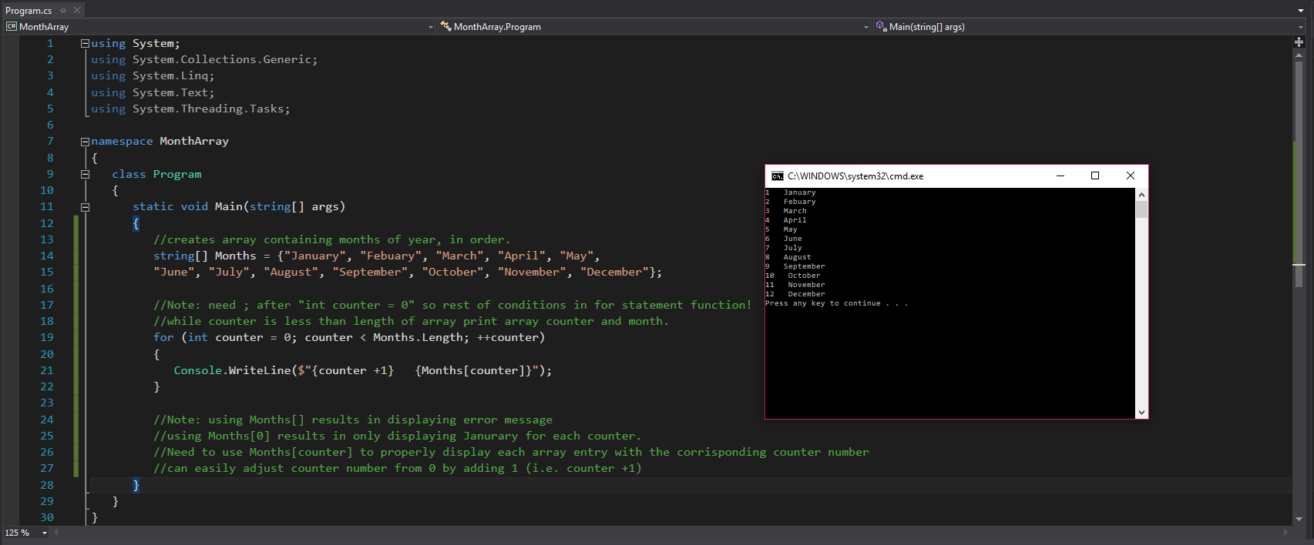

1. Create a 4-element array to store the names of 4 seasons. Use a foreach loop to display the name of each season. (5 points)

using System;

using System.Collections.Generic;

using System.Linq;

using System.Text;

using System.Threading.Tasks;

//Purpose: display seasons with corresponding counter number from an array.

namespace MonthArray

{

class Program

{

static void Main(string[] args)

{

//creates array containing seasons of year, in order.

//Strings in array require "" to function properly, otherwise produces error

//initialize counter variable to display number with array entries.

string[] Seasons = {"Spring", "Summer", "Autumn", "Winter"};

int counter = 1;

//Note: "var value in Seasons" allows foreach loop to work with string values.

//while counter is less than length of array print array counter and season.

foreach (var value in Seasons)

{

Console.WriteLine($"{counter} {value}");

++counter;

}

}

}

}

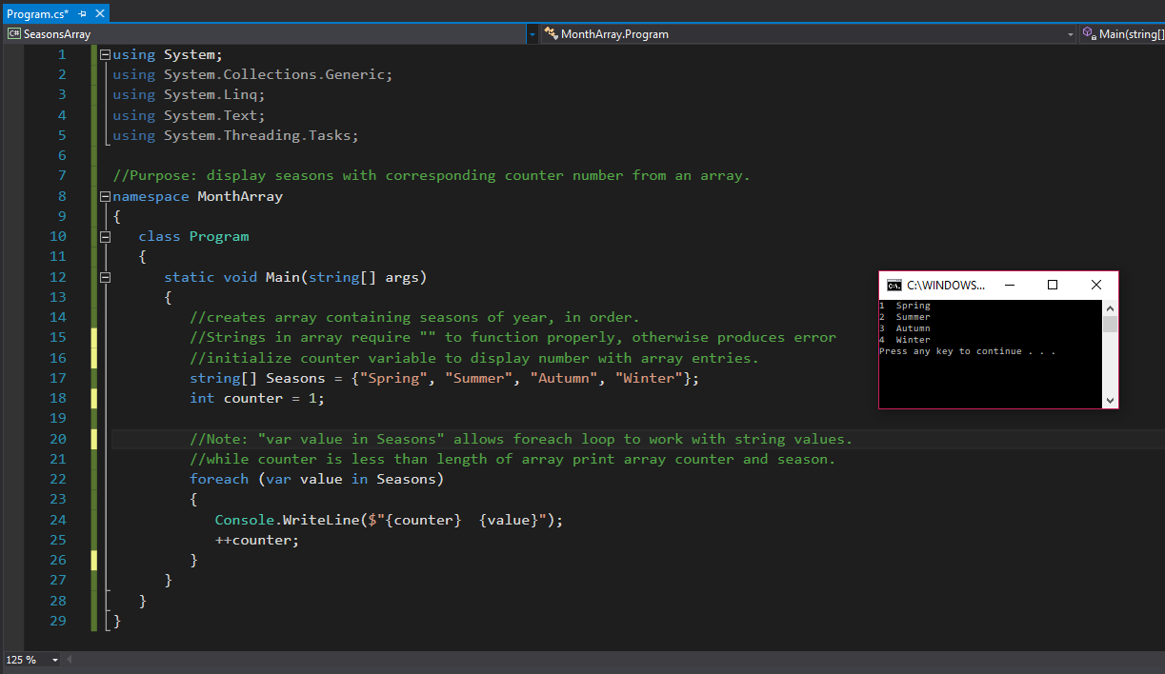

1. Compute the average of the elements of the given array and then output the average. (5 points)

int[] numbers = new int[10];

Add these numbers to the array

87, 68, 94, 100 , 83, 78, 85, 91, 76, 87

The output should be like this:

The average is ……

using System;

using System.Collections.Generic;

using System.Linq;

using System.Text;

using System.Threading.Tasks;

namespace AverageofArray

{

class Program

{

static void Main(string[] args)

{

//intialize & add values to array numbers

int[] numbers = { 87, 68, 94, 100, 83, 78, 85, 91, 76, 87 };

//initialize variables total & average

double total = 0;

double average = 0;

for (int counter = 0; counter < numbers.Length; ++counter)

{

total += numbers[counter];

}

average = total / 10;

Console.WriteLine($"The average is {average}.");

}

}

}

Note: I realized a day later that I used the wrong variable at the end to display the “average”. I corrected it in the second image. Also noticed that variables needed to be double for correct output so I changed that too.

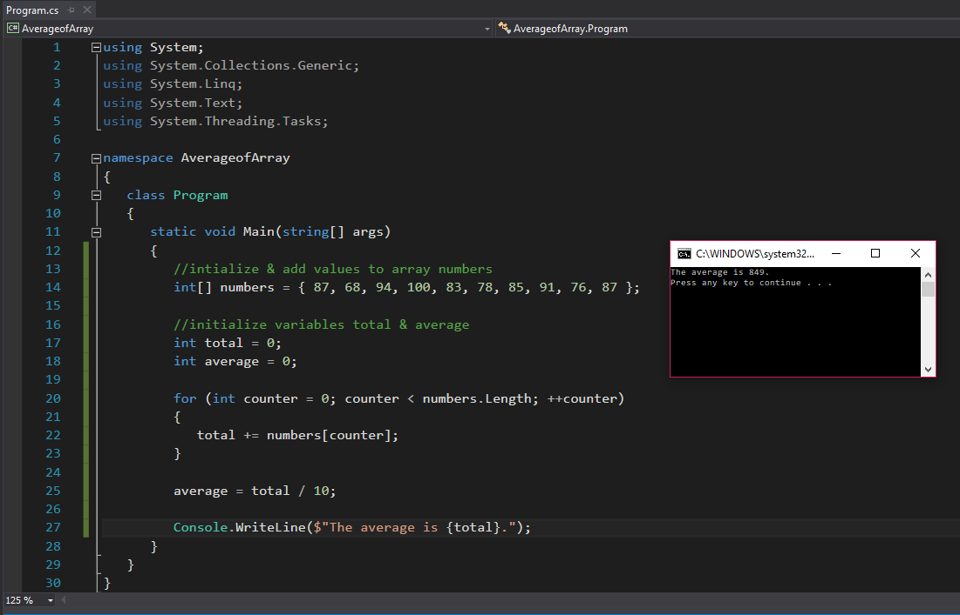

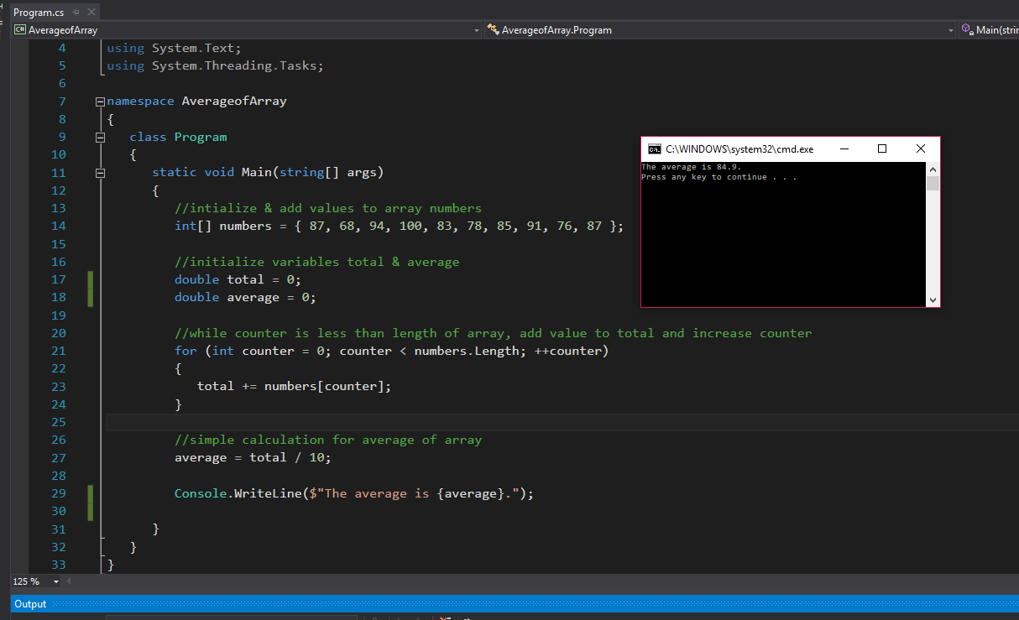

1. Compute the sum of each row of this array and output the results. (5 points)

int[,] numArray = {

{45 , 30 , 70},

{60 , 14 , 88},

{90 , 44 , 23}

};

The output should be like this:

Sum of row o is ……

Sum of row 1 is ……

Sum of row 2 is ……

using System;

using System.Collections.Generic;

using System.Linq;

using System.Text;

using System.Threading.Tasks;

namespace SumArrayRow

{

class Program

{

static void Main(string[] args)

{

//initialize array with multiple rows/columns

int[,] numArray =

{

{45 , 30 , 70},

{60 , 14 , 88},

{90 , 44 , 23}

};

//Initializes sum variable for rows

int Row0Sum = 0;

int Row1Sum = 0;

int Row2Sum = 0;

//test for later experiment. Comment out once done.

/* Note: [0,0] starts the array. This array is only [2,2] in length (total 3 rows and 3 columns). [0,3] creates out of bound error.

Console.WriteLine($"{numArray[0, 0]}");

Console.WriteLine($"{numArray[2, 2]}");

Console.WriteLine($"{numArray[1, 1]}"); */

//There may be a better way to do this, but getting a loop to correctly add each row separately was frustrating. keep it simple!

Row0Sum = numArray[0, 0] + numArray[0, 1] + numArray[0, 2];

Row1Sum = numArray[1, 0] + numArray[1, 1] + numArray[1, 2];

Row2Sum = numArray[2, 0] + numArray[2, 1] + numArray[2, 2];

//Display sums of each row to user's console.

Console.WriteLine($"Sum of row 0 is {Row0Sum}.");

Console.WriteLine($"Sum of row 1 is {Row1Sum}.");

Console.WriteLine($"Sum of row 2 is {Row2Sum}.");

}

}

}

